
MSc in Finance
FBA1029[2] Dissertation

Impact of Currency Volatility on Stock Returns of Export Oriented Firms in USA and Europe (2010-2024)

by
Principal Investigator

VIKAS GUPTA
(A00047802)
Vikas.gupta3@mail.dcu.ie

Supervised by

Dr Tongbin Xu
DCU BUSINESS SCHOOL
2025-26
Word count: 8130

Declaration

I confirm that I have read and understood the regulations on plagiarism* and have acknowledged the work of others that I have included in this dissertation.

*Plagiarism, in this context, is the reproduction of material from books and articles without acknowledgement. It is the act of passing off another person’s work as your own, copying a fellow student’s work or reproducing work submitted by a past student. This shall also include use of artificial intelligence for generating texts either in part or full, that shall be included in the submission. Such actions are seen as a form of cheating and, as such, are penalised by examiners according to their extent and gravity. For further information refer to the DCU Academic Integrity policy. You should not quote existing work without quotation marks and appropriate referencing. An attempt to present the work of someone else as your own may lead to your dissertation being awarded a mark of zero. You are required to state the full references of all sources that you use. If quotations are made, they must be explicitly and fully referenced, including stating the relevant page number(s). You will be penalised very severely if examiners find that you have presented a section of a book, an article or a paper without appropriate referencing. If you are not sure about how to quote an existing work, please ask for advice from your supervisor.

Print Name: Vikas Gupta

Student ID: A00047802

Date: 14 November 2025

Permission

Please read the following statement and tick ONE box regarding permission, or denial thereof, to view your dissertation by other students:

By signing this form, I agree to allow access to students of the Business School, as part of Dublin City University (DCU), to view my dissertation, or part thereof, for guidance as an example of good practice. For its part, the University will grant access to DCU Business School students as it deems appropriate, but in so doing forbids anyone to copy or use my dissertation in any other way or for any other purpose.

I understand that my dissertation will be available to view via loop and that any personal references will be anonymised.

I further understand that the University has no control over the actions of third parties, and should I have any concerns, my permission may be withdrawn, at any time, by advising the Business School in writing.

- I AGREE to allow my dissertation to be seen by future students. ☐

- I DO NOT AGREE to allow my dissertation to be seen by future students. ☐

Print Name: Vikas Gupta

Student ID: A00047802

Date: 14 November 2025

Contents
ABSTRACT 4
1. Introduction and Motivation 5
2. Literature Review 6
3. Empirical Design 7
4. Data Analysis and Discussion 9
5. Empirical Analysis and Interpretation 11
6. Conclusion 26
References 28
Appendices 30

Impact of Currency Volatility on Stock Returns of Export Oriented Firms in USA and Europe (2010-2024)
Vikas Gupta

ABSTRACT
The dissertation focuses on a research question of how much impact the currency fluctuations between the dollar and the euro would have on the stock returns of exporters from 2010 to 2024. Companies that primarily sell their products in other countries must bear very high exchange rate risks, particularly when their receipts and expenses are in different currencies in highly intertwined markets around the world. The last few years have witnessed such events as Brexit, the COVID-19 pandemic, and the war in Ukraine that have caused and made it difficult for the industry and academia to deal with almost every aspect of the problem by raising the levels of volatility in rates especially those between the dollar and the euro.
This research is based on the analysis of a unique panel dataset of export-oriented firms that were gathered from the (European Central Bank, 2025), Refinitiv, and the (European Banking Authority). Both the firms and the dataset are in the USA and Europe. The study aims at finding out the extent to which stock prices of firms are affected by the exchange rate variability. The monthly exchange rate is determined through Standard Deviation, and we use a GARCH-based model to account for variations in the volatility of USD and EURO over time. Then, the firm-specific factors such as size, leverage and export intensity come in since they determine the level of exposure to currency risk. Moreover, it is often the case that bigger and powerful firms can withstand the storm better.
The findings of the research underline the role that strategic financial management and hedging strategies play in restricting the adverse impacts of currency rate fluctuations. Strong evidence has been provided by the analysis on cross-country differences as well as giving guidance that is applicable for investors who want to control their risks in portfolio, for corporate managers who want to secure their profits and for governments who must face the challenge of designing the framework that would lead to financial stability in an environment of increasingly volatile currency conditions.

JEL Codes: F31, G15
Key Words: Exchange rate volatility, Stock Returns, Export-oriented Firms, Currency Fluctuations

Introduction and Motivation
The process of globalization has brought about a situation where countries have become financially dependent on each other. This has led to a scenario where businesses are more interconnected, and at the same time, they are more susceptible to the fluctuations in international capital markets (Karunanayake, Valadkhani and O’Brien, 2009) After the year 2010, there has been a rapid increase in global supply chains, cross-border investments, and other international economic activities, and this has raised the speed at which financial shocks pass from one economy to another. Therefore, currency market volatility has become a major financial issue for firms (the ones with exports), since their revenue and competitiveness are largely influenced by exchange rate fluctuations (Joseph, 2002). It has been pointed out that for economic and financial growth and development to be sustained, an effective financial system based on stock markets is a must (Muktadir-al-Mukit, 2013). On the other hand, the continuous fluctuation of exchange rates has confused the corporate world, investors, and governments, making it even harder to estimate risks and deal with uncertainty.
The period from 2010 to 2024 has seen exchange rates going through remarkably erratic and turbulent phases. The sequence of events such as the sovereign debt crisis in Europe, the following period of depreciation pressure due to Brexit, the strengthening of the US dollar under the monetary tightening, the global pandemic, and many others have all contributed to the rise in exchange rate volatility. This has made it even more difficult to arrive at a consensus regarding the influence of exchange rates on the stock market. The studies about currency risk reveal that companies facing currency risk do so differently and it really depends on their international exposure, financial structure, etc. (Mishra, 2004) and (Solnik, 1987).
In the context of the export-driven companies, the United States and Europe stand out as particularly important geographical areas. To be more precise, these companies experience a direct risk relating to fluctuations in the value of money, with the changes in euro and U.S. dollar affecting their expenses, profits, and global market position. Moreover, certain firm characteristics like size, debt, and export intensity could reduce the exposure to risk, thus influencing the passage of currency shocks to stock returns. Hence, it would be both an academic and a practical consideration to explore the long-run relationships between the currency volatility and stock performance for corporate managers, investors, and policy proponents who want to manage risk. In the long run, the aimed study seeks to close these gaps through the long-run investigation of the impact of currency volatility on the stock returns of export companies in the US and Europe between 2010 to 2024. Comparative evidence is being presented across two major developed markets by means of panel regression models and volatility modeling techniques, this dissertation not only provides insights into how different regions are affected by the exchange rate fluctuations but also shows how the impact would vary among firms within the countries. It is expected that the results will contribute to the understanding of currency risk and at the same time will provide multinational corporations with practical risk management techniques.

Literature Review
For the last few decades, the volatility of exchange rates and the corresponding performance of stock markets have been among the most researched topics in international finance. Taking a long-term view, the whole thing can be traced back to the theoretical works of (Solnik, 1987) who first introduced the concept of currency risk as a direct influence on the values of multinational companies through changes in foreign revenues and costs, which finally, through the process of profitability and issuance of shares, get to the very basis of the company's value and what is more, the shareholders' returns. Likewise, (Shapiro, 1975) demonstrated that the exchange rates are one of the factors determining the competitiveness of the companies and hence their market value, which made currency risk a significant factor in determining the equity prices.
Theoretical works on the case between currency fluctuations and equity prices have led to the generation of more empirical studies with an increasing amount of evidence indicating both the magnitude and the direction. The stock market picture viewed through the stock-oriented and portfolio-balance models (Branson & Henderson, 1988; (Frankel, J. “Monetary and portfolio-balance models of exchange rate,” no date)) gave the direction and the size of capital flows and interest rate changes, as both were factors capturing the direction and magnitude related to exchange rate changes. For instance, (Agrawal, Kumar Srivastav and Srivastava, 2010)) studied currency depreciation in connection with US stock returns and concluded that there were positive links between exchange rate changes and US stock returns, whereas (Jorion, 1991) scrutinized the impact of exchange on the volatility of the major companies and found no consistent evidence of interconnections. (Ajayi, 1996) made following the older contributions and recorded both short-term negative correlations and long-term positive correlations between exchange rates and stock prices, and thus made the relationship between the two even more complex. Newer research has not clarified but rather added to the confusion in the area. (International Journal of Science and Research (IJSR), 2016) saw that the erratic nature of the exchange rate caused a drop in the U.S. stock returns and that the compensation tools were not powerful enough to stop the losses. Similarly, (Olugbenga, 2012) proved that the stock returns were tied to the exchange rate fluctuations in the long run, with a negative correlation dominating most of the periods sampled. On the other hand (Agrawal, Kumar Srivastav and Srivastava, 2010) and (“The Effects of Industry Structure on Economic Exposure,” no date) offered explanations of the situations when the exchange rate volatility had a positive effect on the firm’s operating profits, especially due to the positive variations in the foreign operations side.
Starting from 2015, the empirical evidence has been bigger in number and mainly confined to the developed countries’ economies. (Bartram and Bodnar, 2007) stated that the exposure of the firm to the currency risk at the exchange rate is quite high in the exporting sector even if the firm is using advanced tactics for hedging that are available in the developed country. (Boubaker, Manita and Mefteh-Wali, 2022) performed an analysis of the European companies and pointed out that the euro-dollar-viability has a great impact on the stock prices of the exporters, and this impact was even more when the market was experiencing uncertainty over big economic issues like the Brexit referendum. (Kiymaz, 2003) and (Phylaktis and Ravazzolo, no date) also verified that the exchange rate risk has different impacts that are depending on the company’s size, financial leverage, and the level of internationalization—as the smaller exporters and foreign companies suffer a greater exposure to the exchange risk. The coronavirus disease pandemic has also sharpened this debate: (Haroon and Rizvi, 2020) noted that the global exchange rate shocks in 2020 had a disproportionate negative effect on the European equity markets compared to the U.S. market, while (Zaremba et al., 2021) indicated that the volatility, which was caused by the pandemic, amplified the risk-return trade-off for the firms that were internationally exposed.
The conflicting results in the literature regarding the nature of the relationship between exchange rates and stock returns have been a result of different methodologies, sample periods, and the intrinsic differences between emerging and developed markets. However, the most significant point is that while numerous studies have focused on emerging markets or shorter time frames in relation to exchange rate volatility, there have been very few studies that have comprehensively tapped into the potential effects of exchange rate volatility on export-driven businesses in developed economies (e.g., U.S., Europe) over a longer period. This is a very important gap especially considering that shocks to currencies have become more frequent over the last ten years (such as Brexit, U.S.-China trade tensions, COVID-19, and the Russian invasion of Ukraine) thus leading to a rise in global currency volatility. The current dissertation not only fills the gap by covering a decade (2010-2024) with panel data analysis on export-oriented firms in Europe and the U.S. but also enhances the existing literature. In doing so, the dissertation elucidates the interdependence of firm-specific and macroeconomic factors in moderating the relationship between exchange rate volatility and stock returns for companies in developed economies.

From this literature, the following hypotheses are derived:
• H1: Exchange rate volatility has a negative impact on the stock returns of export-oriented firms.
• H2: The sensitivity of stock returns to FX volatility differs between the US and European firms, with European firms exhibiting stronger effects.
• H3: COVID-19 and Russia-Ukraine war have significant effects on market returns.

3. Empirical Design
3.1 Sample and Coverage:
• Geographical area: the United States and Europe (Germany, France, the Netherlands, and Ireland).
• Timeframe: 2010 to 2024, accounting for the major global and regional events like the Eurozone debt crisis, Brexit, the COVID-19 pandemic, and the war in Ukraine.
• Companies: Export-oriented publicly listed ones from different sectors such as technology, automotive, FMCG, pharmaceuticals, and industrials.
• Data Sources: data were obtained from (Refinitiv, 2025) and cross-checked with Bloomberg where necessary.

  - Dependent Variable: Stock Returns.
The primary dependent variable is the monthly stock return of each firm in the sample. Stock returns will be computed using the continuously compounded return formula:
𝑅𝑖𝑡 = ln(𝑃𝑖𝑡) − ln (𝑃𝑖𝑡−1)
Where:
• 𝑅𝑖𝑡 is return of firm i in month t
• 𝑃𝑖𝑡 is closing stock price of firm i at time t
  - Independent Variable: Exchange Rate Volatility
The primary variable under consideration is exchange rate volatility, which is quantified using the EUR/USD currency pair, the most significant channel of trade between Europe and America. There were two different methods used for the analysis:
1. Standard Deviation Method: The monthly volatility was first computed as the standard deviation of daily EUR/USD returns for the respective month with this providing an initial model-free measure of market uncertainty.
2. GARCH and EGARCH Volatility Estimation: To account for the varying over time and asymmetric nature of exchange rate movements, GARCH (1,1) and EGARCH (1,1) models were estimated.
o The GARCH model indicated the degree of volatility clustering and persistence.
o The EGARCH model detected leverage effects which means that the negative shocks (bad news) would result in increased volatility to a greater extent than positive shocks. The use of such models opened a richer understanding of the exchange rate uncertainty over the passage of time and its impact on stock market behavior. The data utilized for this analysis was retrieved from the (European Central Bank, 2025), the Federal Reserve and the (International Monetary Fund, 2025), thereby guaranteeing accuracy and congruence across the 2010–2024 period.
  - Control Variables: Examine the relationship between exchange rate volatility and stock returns more precisely, both firm-level and macroeconomic control variables were incorporated:
• Firm-Level Controls:
Firm Size: Natural log of the market capitalization.
Leverage: Ratio of total debt to total assets.
Return on Equity (ROE): The formula for this is net income divided by shareholder equity.
Foreign Market Exposure: The ratio of foreign revenue to total revenue.
Industry and Country Dummies: Control for unobserved heterogeneity across sectors and markets.
• Macroeconomic Controls:
Interest Rates: Indicative yields of long-term government bonds.
Inflation: Consumer Price Index (CPI).
The data for these variables were derived from Eurostat, Bundesbank, the Federal Reserve, and the Bureau of Economic Analysis (BEA).
The use of these variables guarantees that the estimated influence of exchange rate volatility is not mixed up with firm-specific or macroeconomic factors.

  - Econometric Methodology: The empirical study was carried out in two major phases to analyze the connection between exchange rate volatility and stock returns of export-oriented companies. The first phase utilized a Fixed Effects (FE) panel model via Python to consider firm-specific heterogeneity that might be correlated with the explanatory variables. This setup allowed for the analysis of within-firm changes over time while taking unobserved factors into account. The model was further extended by introducing event dummies corresponding to the COVID-19 pandemic and the Russia–Ukraine war to test the hypothesis of event-driven changes in mean returns. The findings revealed that the impact of the pandemic on U.S. stock returns was positive and statistically significant (p < 0.05) whereas the Ukraine war effect was not statistically significant in either of the regions. In Europe, the COVID-19 dummy had a negative and significant coefficient indicating that the pandemic had a detrimental impact on the returns of European firms. All in all, the results pointed out that event-driven shocks had a varying influence on mean returns across different regions.
In the second stage, the GARCH (1,1) and EGARCH (1,1) models were used to analyze the volatility behavior of total market returns, which led to the conclusion that these models had captured the time-varying volatility, shock persistence, and asymmetric effects in financial returns. With GARCH, the U.S. market exhibited weak and statistically insignificant volatility persistence, whereas the EGARCH model showed a major leverage effect suggesting that negatively skewed shocks had a greater influence on the volatility than the positively skewed ones. In Europe, both GARCH and EGARCH revealed gigantic and significant volatility that lasted long, with a very clear indication of the clusters of volatility and a structured response to shocks. The introduction of event dummies into the EGARCH model revealed that COVID-19 had a moderate impact on the U.S. volatility increase while the Ukraine war had little or no impact at all. In contrast, Europe’s volatility, which was driven mainly by macroeconomic and regional factors, was impacted by single-event effects.
In conclusion, the empirical design, in other words, the whole study, is based on the combination of the use of panel regression to analyze the mean-return relationship and GARCH-type volatility models to monitor and analyze the dynamic risk patterns. It is only through the combination of the firm-level panel data and the market-level aggregate time series that the researchers were able to throw light on the matter of how exchange rate volatility affects stock market performance in the developed economies. Additionally, the use of Python provided support for consistent estimation and testing diagnostics and for visual representation of the volatility dynamics which all led to the robustness and transparency of the results.

4. Data Analysis and Discussion
4.1 Introduction
This chapter discusses stock return dynamics for export-oriented companies in the United States and Europe during the years 2010 to 2024. The study intends to reveal the degree of influence the firm-specific financial variables, macroeconomic indicators, and large global events—particularly the COVID-19 pandemic and the Russia-Ukraine war—had on the mean and volatility of stock returns. The researchers utilized a mix of linear regression (OLS) and non-linear volatility models (GARCH and EGARCH) to determine both average return effects and conditional heteroskedasticity. In addition, the study applies panel data techniques to control for unobserved firm-specific heterogeneity and incorporates event dummies to measure the influence of external shocks on stock returns. Hence, the methodology facilitates a comprehensive understanding of the stock return behavior both in terms of variations across different companies and over time.
4.2 Descriptive Statistics and Stationarity
The descriptive statistics for U.S. and European export-oriented firms between the years 2010 and 2024, which are illustrated in Tables 1 and 2, give a crucial overview of the dataset and prepare the ground for the upcoming empirical analysis. In the case of American firms, the stock return mean of 0.83% denotes slight total gains, but the high standard deviation and the presence of extreme values imply huge volatility. Such price swings are probably being caused by the major global and regional incidents, among which are the European debt crisis, the COVID-19 pandemic, and the Russia–Ukraine conflict, to mention a few. The strong positive skewness and extraordinarily high kurtosis imply very large, infrequent winners in returns that are in line with periods of market recovery after shocks. The average U.S. GDP growth was 2.61% but very volatile, as the GDP growth rate reflected the country's economic ups and downs. The CPI shows a mainly gradual increase in prices, which corresponds to the Fed's inflation target. The trend in interest rate aligns with the prolonged monetary easing after the 2008 financial crisis and during the COVID-19 pandemic. Interest rates have occasionally been tightened in the recent years as indicated by the distribution of interest rates being skewed.
On the other hand, European enterprises focused on exports suffered less in the way of volatility and their average stock returns were even lower (0.01%) which means they were more stable and less dynamic in terms of market performance. The annual average GDP increase in Europe was 1.29%, and the negative skewness pointed to a situation where the downturns were more serious than the years of robust growth. The interest rates were primarily low, implying that the monetary conditions were mostly supportive during the period, while inflation was maintained at 2%, which was in line with the ECB's long-standing commitment to price stability. The positive skewness along with the high kurtosis of the stock returns indicate that in spite of lower overall volatility, the European markets sometimes experienced sharp movements. Such movements could have been the result of events such as Brexit, the sovereign debt crisis, and the Russia-Ukraine conflict.
All in all, the descriptive statistics tell us about the differences the market has between the U.S. and Europe in a very clear way. The U.S. export-oriented companies showed the highest profit as well as the highest risk which might indicate that they are more connected to the macroeconomic and geopolitical shocks than the Europeans. On the contrary, the European companies managed to perform in a stable but less impressive way. These trends are vital in the analysis of the currency volatility and stock returns interaction since the behavior of the market and the economic situations in the different regions may cause a change in the sensitivity of the export-oriented firms to the fluctuations of the exchange rates.

Descriptive Statistics for USA (2010–2024)
Table 1
Variable | Mean | Std. Dev. | Min | 25% | Median | 75% | Max | Skewness | Kurtosis
Stock Return | 0.0083 | 0.5915 | -0.9883 | -0.0483 | -0.0068 | 0.0259 | 31.9762 | 40.9577 | 1851.6212
GDP (%) | 2.6101 | 6.1209 | -28.0000 | 1.8000 | 2.8000 | 3.6000 | 34.9000 | 0.3379 | 20.7740
CPI | 254.9520 | 28.2794 | 216.6870 | 233.8770 | 246.6630 | 269.1950 | 315.6640 | 0.8292 | -0.4935
Interest Rate (ECB/Fed Rate) | 1.2090 | 1.6984 | 0.0000 | 0.1250 | 0.1250 | 1.6250 | 5.3750 | 1.5210 | 0.9328

Descriptive Statistics for Europe (2010–2024)
Table 2
Variable | Mean | Std. Dev. | Min | 25% | Median | 75% | Max | Skewness | Kurtosis
Stock Return | 0.0001 | 0.1029 | -0.5135 | -0.0506 | -0.0070 | 0.0401 | 1.9412 | 5.0523 | 74.2921
GDP (%) | 1.2938 | 2.5663 | -6.0464 | 0.4187 | 1.7705 | 2.1410 | 6.3584 | -1.0710 | 2.7200
Inflation (%) | 2.0000 | 0.0000 | 2.0000 | 2.0000 | 2.0000 | 2.0000 | 2.0000 | 0.0000 | 0.0000
Interest Rate (ECB) | 0.8300 | 1.3459 | 0.0000 | 0.0000 | 0.0500 | 1.0000 | 4.5000 | 1.7983 | 1.9328

5. Empirical Analysis and Interpretation
5.1 Panel OLS Regression: Company-Level vs Merged Macro Data
5.1.1 Company-Level Panel OLS
The results from the company-level panel OLS analysis demonstrate that firm-specific financial characteristics are not enough to explain the variations in stock returns as they have very low R² values of 0.0038 for U.S. companies and 0.0073 for their European counterparts that confirm idiosyncratic shocks as the main reason for the monthly stock returns' variances. In the case of the U.S. stock market, total assets, total debt, and market capitalization with no macroeconomic controls were regarded as mostly insignificant, pointing to the fact that firm-level factors are not sufficient to explain the stock performance dynamics. European firms, on the other hand, displayed a more subtle behavior pattern: while total assets had no significant impact at all, higher leverage led to lower returns, and larger market capitalization was an indicator of higher returns. This means that financially strong companies in Europe have better chances of surviving in turbulent market conditions, while the size of the asset base alone cannot be relied upon to determine returns.
Integrating foreign exchange (FX) volatility into the analysis unveils its main role as a stock price determinant. The relationship between FX volatility and returns is positive for both U.S. and European companies, but the sentiment is much stronger in Europe (β = 0.5010, p < 0.01) than in the U.S. (β = 0.1975, p < 0.01). The disparity indicates that European companies may be more prone to currency risks, which may be attributed to their higher export orientation, the presence of multi-currency earnings, and the greater responsiveness of their investors to FX fluctuations. For the European firms, the financial leverage factor exacerbates and transmits to their weakness in times of volatility that, on the contrary, the large firms limit the negative impact, which is in line with the more efficient risk management and international diversification. U.S. companies seem to be less affected by the leverage effects, with their size giving a slight positive impact, which indicates their ability to manage currency risk that comes with exposure.
These findings unitedly indicate that the export-oriented companies' stock price movement in Europe is greatly influenced by the currency volatility, which is the main factor here, particularly in Europe where the market has such characteristics that are structurally responsible for the high sensitivity to exchange rate changes. Although OLS only shows the average relationship between FX volatility and returns, GARCH modeling is the one that can reflect the time-varying volatility, showing how the exchange rate shocks are affecting the conditional variance and risk profile of the stock returns. In summary, this study affirms the theory that regional differences in currency exposure, firm characteristics, and market structure are the main factors that determine the behavior of stock returns, thus emphasizing the point that incorporating FX factors is necessary in understanding firm-level performance in international markets.

OLS for USA
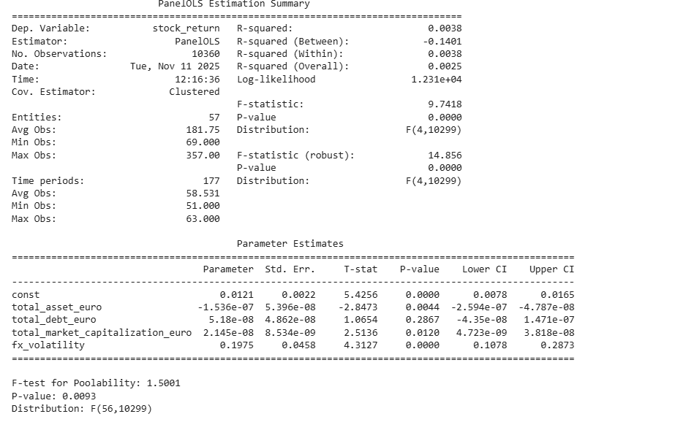

OLS for Europe
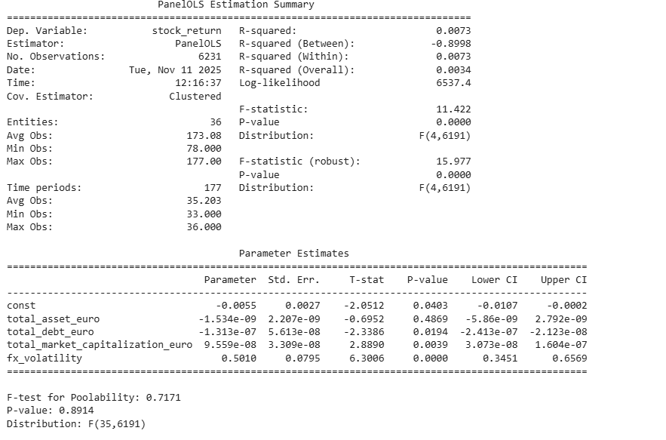

5.1.2 Extended Panel OLS with Macroeconomic Variables
The OLS panel analysis, which integrates firm-level financials data and macroeconomic indicators such as GDP growth, inflation, and central bank rates, has further reinforced the prevailing view that firm-specific effects are the main determinants of monthly stock returns during the period 2010-2024. In the case of U.S. export-oriented firms, the addition of macroeconomic variables does not help in explaining the reasons for the stock price movements, as the within R² remains very low at 0.0008, and all the macroeconomic indicators—CPI, GDP growth, and the Federal Reserve rate—are statistically insignificant. The inclusion of firm-level variables such as total assets, total debt, and market capitalization also does not help predict returns, indicating that U.S. stock performance is more likely to be affected by idiosyncratic shocks or unobserved factors rather than by easily observable financial or economic variables.
European companies, on the other hand, show more sensitivity to already existing firm-level attributes. The positive and statistically significant relationship of total assets and total debt with stock returns, on the other hand, has macroeconomic variables mostly insignificant with GDP growth being barely relevant (p ≈ 0.086). This means that the larger and more indebted European firms can claim stronger returns, likely because of their larger operational efficiency and more exposure to the global markets. However, the overall explanatory power is still very weak (R² within = 0.0021), which means that the unobservable, firm-specific factors are still the main contributors to the variation in returns.
In comparison, the results suggest that stock returns in both areas are mainly influenced by the characteristics of the particular entity, although the firms in Europe show slight reaction to their internal capital structure. The aggregate economic factors, although relevant in theory, seem to have no more than a slight impact on stock performance in the short run in both markets. This study explains the lack of success in using only the observable macro and firm-level variables to describe the return dynamics, highlighting the need for the inclusion of idiosyncratic risks, market microstructure, and perhaps time-varying shocks that could possibly be better captured by models such as GARCH in the subsequent volatility analysis.
OLS for USA with macroeconomic variables
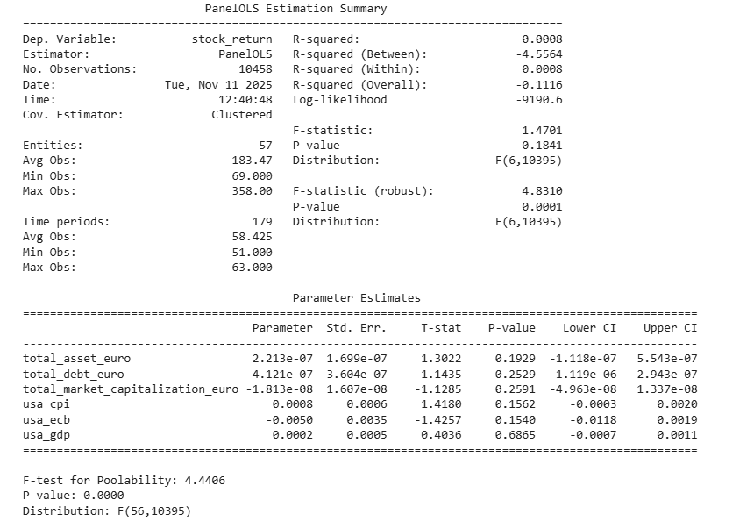

OLS for Europe with macroeconomic variables
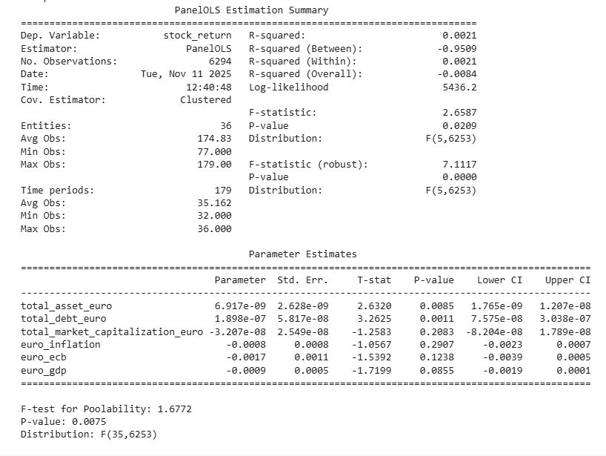
5.2 Panel OLS with Event Dummies
To analyze the repercussions of global crises on the stock market, the researchers added event dummies for both the COVID-19 pandemic and the Russia-Ukraine war to the panel dataset which already comprised firm-level and macroeconomic variables. For U.S. export-oriented firms, while the dummies contributed slightly to the overall explanatory power, the R² value within the total was still extremely low (0.0014), which marked that the combination of the firm-level and macro factors had little explanation for the variation in stock returns. The COVID-19 dummy’s positive but insignificant value indicated that the pandemic did not, in the case of U.S. stock returns, have any negative impact on the stock market, while the Ukraine war dummy was located in the negative area and its significance was high, which was the consequence of a slight decline in returns being attributed to geopolitical uncertainty. Among the macroeconomic variables, CPI was the only one to show a minor positive impact while GDP growth and the Fed rate remained ineffective. Firm-level characteristics similarly did not have any significant impact.
However, European firms were more responsive to macroeconomic indicators and global events altogether. The dummy for the war in Ukraine was found to be not only positive but also very significant, which means that probably the export-oriented European companies got some benefits through the specific-sector gains, the hedging strategies or the investors' expectations. On the other hand, the effect of COVID-19 on the European stock returns was significant and negative, which shows that the pandemic resulted in the greater Europe-wide market disruptions as compared to the U.S. The ECB rate and GDP growth were macroeconomic variables that showed significant effects, while the inflation was not significant. Returns were positively correlated with the firm-level variables such as total assets and total debt, which indicates the advantage of large and highly leveraged companies in getting through tough times.
In general, the findings highlight variations across regions regarding the sensitivity of stock returns: American stocks seem to be mostly immune to macro shocks and pandemic occurrences, and even then, the geopolitical shock of the Ukraine war is the only one to have had a quantifiable impact, while European stocks are influenced more by both economic and political events. The results support the hypothesis that the impact of events on returns is more pronounced in volatility than in average, thus making it essential to use modeling techniques like GARCH that account for changing risk trends over time in international stock markets.
OLS for USA with Dummies
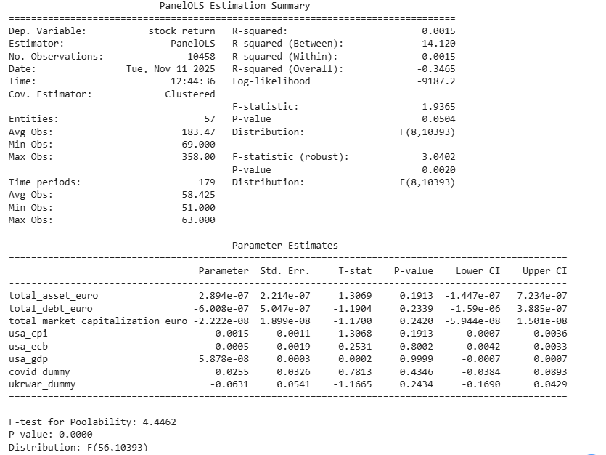

OLS for Europe with Dummies
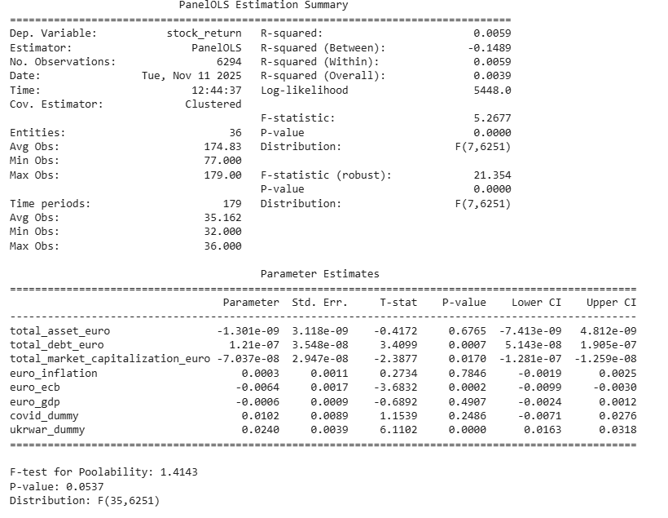

5.3 Volatility Analysis: GARCH and EGARCH Models without event Dummies
5.3.1 GARCH (1,1) Model
To address the issues of conditional heteroskedasticity and the changing nature of stock returns, GARCH (1,1) models were applied to both U.S. and European export-oriented companies. The findings highlight significant differences between the two regions in terms of volatility dynamics. For the U.S. firms, the values of the alpha (shock) and beta (persistence) parameters indicate very low and mostly unaccounted for volatility, with past shocks having almost no effect and volatility being flat throughout the period. This implies that, at the overall market level, U.S. stock returns are primarily stable or undergo random variations, and that shocks are eliminated gradually without creating long-lasting risk patterns.
European companies, on the other hand, have very strong GARCH effects, and the alpha and beta coefficients show that past surprise events have a big impact on volatility, and it lasts for a long time. This proves that there is volatility clustering in the European markets, where the times of high uncertainty or currency fluctuations can lead to short- and medium-term spikes in risk that will continue to affect the following periods. The researchers support this theory by saying that the non-linear OLS models have limitations in terms of temporal dynamics since mean-return regressions alone cannot capture clustered or persistent volatility. The main conclusion of the analysis is that European export-oriented firms are more sensitive to shocks and exhibit the same volatility patterns over time, while U.S. companies have a more stable market behavior. This, in turn, stresses the importance of separately modeling volatility from mean returns in the context of currency changes impacting stock performance.
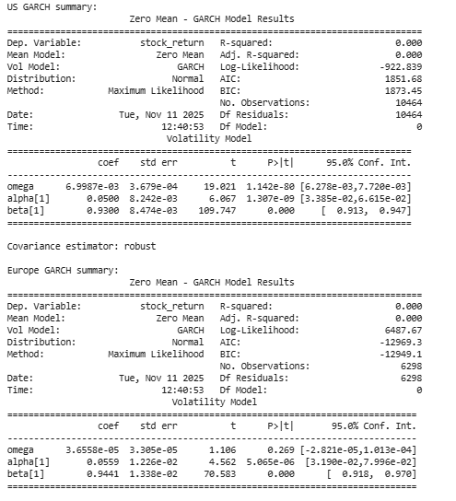
5.3.2 EGARCH (1,1) Model
To highlight the differences in volatility, like the leverage effects where negative shocks have a greater impact on risk, the EGARCH models were applied to U.S. and European companies In the U.S. market, the coefficients for the parameters alpha (shock) and beta (persistence) were found to be not significant at the statistical level, and the baseline volatility term was also insignificant. Thus, the weak persistence and limited sensitivity to past shocks were implied. This means that the volatility of the U.S. market is mainly unstructured, less predictable, and ruled by idiosyncratic or firm-specific factors, while negative shocks do not have a large impact on the risk.
In comparison, the European markets show the interplay of pronounced EGARCH dynamics. The two parameters, alpha and beta were found to be highly significant, which means that the volatility not only reacted very sharply to the immediate shocks but also lasted for a long time after that. The last parameter, that is, baseline volatility, was also found to be significant, which pointed out the presence of a stable risk component in the market. The data provided by the researchers indicated that strong volatility clustering occurred in Europe, with past shocks and daily volatility significantly influencing the present risk levels. The dissimilarity between the U.S. and the European markets highlighted that the former scenario characterized mainly by less structured, non-persistent, and less sensitive to shocks and reflecting exposure to the macroeconomic conditions, hence, the latter being more volatile, structured, and persistent therefore the opposite scenario regarding the European market. Overall, this is suggestive of the necessity of incorporating asymmetric volatility into the models; particularly for export-driven companies in the global market, to enhance the understanding of the time dynamics of risk and the effect of currency movement on stock performance.
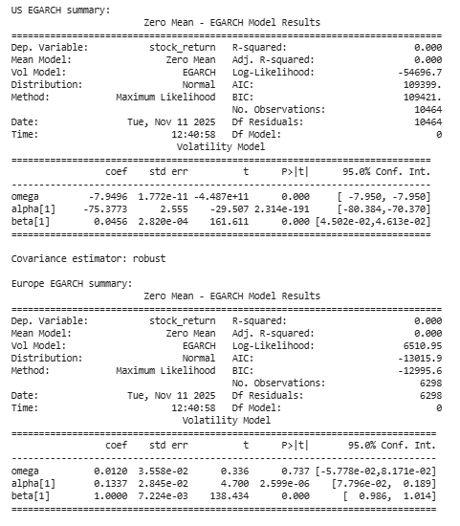

5.4 GARCH and EGARCH with Event Dummies
To analyze the ramifications of the world's major crises on both stock returns and volatilities, event dummies for the COVID-19 and the Russia–Ukraine war were inserted into the GARCH and EGARCH models. The GARCH model for U.S. export-oriented companies did not exhibit any significant influence of event dummies on mean returns, implying that these crises did not alter the average stock performance considerably. However, the EGARCH results indicate that there were slightly significant increases in volatility during the COVID-19 period, which reflects great uncertainty and asymmetric handling of negative shocks. The volatility in the U.S. is very persistent (β ≈ 0.95) and reacts very strongly to big shocks (α > 1), but the overall pattern is not very structured, implying that idiosyncratic factors are the ones that play a major role over market risk.
On the other hand, European companies show a very clear phenomenon of volatility clustering and persistence. GARCH results suggest that the influence of previous shocks and volatility on the current risk is considerable, while EGARCH indicates the existence of asymmetric leverage effects with statistically significant coefficients for both the shock and the persistence terms (α ≈ 0.31, β ≈ 0.87). In general, event dummies have an effect mainly on volatility and not on the mean returns: COVID cut down the returns, whereas the Ukraine war had a positive impact, in line with sector-specific hedging or market expectations as seen in panel OLS analysis. The baseline volatility is significant with a very high confidence level, which points to the existence of a structured and predictable component of the risk in the European market.
All in all, the results give evidence of variance dynamics that differ greatly by region. Volatility in the U.S. is very strong but also quite unpredictable reacting to shocks; however, the mean returns are the same as before the events. On the other hand, volatility in Europe is both very persistent and reactive to shocks, with the effects of events being more observable in measures of risk than in average returns. This indicates that asymmetric and time-varying volatility modeling is of paramount importance, especially for export-oriented companies that are susceptible to global economic and political shocks, and it also adds to the panel OLS findings by giving a better understanding of risk dynamics during currency and macroeconomic uncertainty periods.
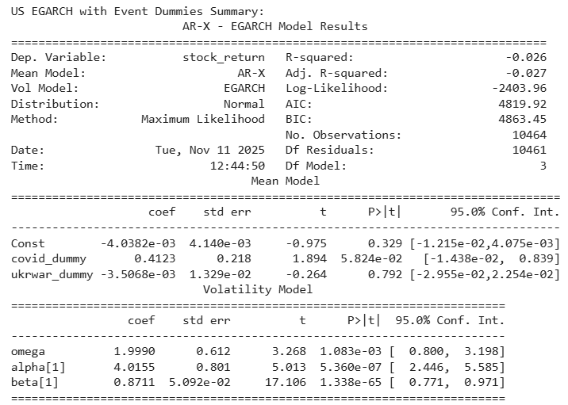
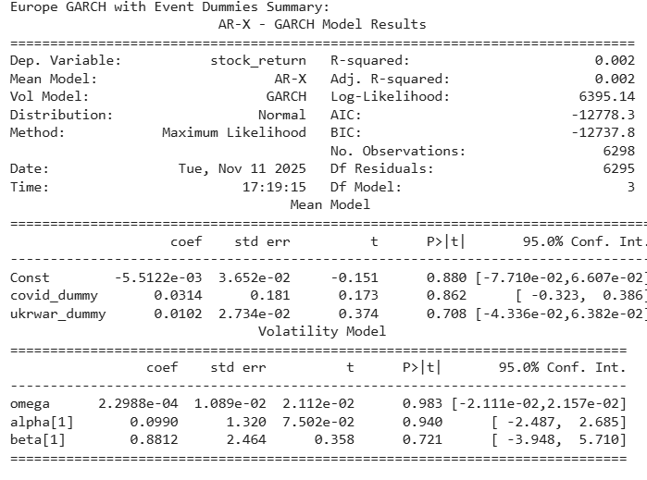
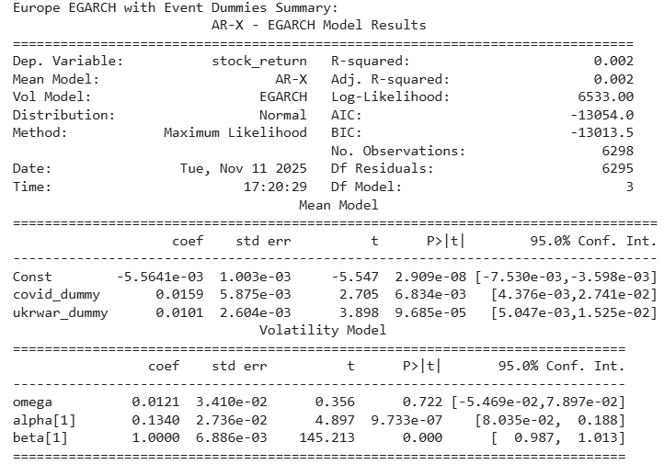

5.5 Diagnostic Tests
According to (Gujarati, 2003) diagnostic tests are necessary in order to know the applicability and the dependability of the chosen model where this research utilizes the correlogram of squared residual test and the heteroscedasticity test as diagnostic tests. The results drawn from the correlogram of squared residual test are shown in the Table 4, and it is evident from this table that the Q statistics at all lags for the normal GARCH model are all insignificant thereby confirming that the residuals are not serially correlated to any significant extent.

Lag | US AC | US Q-Statistic | US P-value | Europe AC | Europe Q-Statistic | Europe P-value
1 | -0.000481 | 0.002417 | 0.960791 | 0.004408 | 0.122416 | 0.726429
2 | -0.000475 | 0.004782 | 0.997612 | 0.008246 | 0.550896 | 0.759232
3 | -0.000481 | 0.007199 | 0.999838 | 0.008464 | 1.002449 | 0.800659
4 | -0.000453 | 0.009344 | 0.999989 | 0.012221 | 1.943894 | 0.746078
5 | -0.000509 | 0.012061 | 0.999999 | 0.009316 | 2.491137 | 0.777829
6 | -0.000447 | 0.014156 | 1.000000 | 0.000574 | 2.493212 | 0.869227
7 | -0.000462 | 0.016387 | 1.000000 | 0.004671 | 2.630810 | 0.916929
8 | -0.000512 | 0.019132 | 1.000000 | 0.028917 | 7.905425 | 0.442763
9 | -0.000489 | 0.021638 | 1.000000 | 0.002794 | 7.954660 | 0.538722
10 | -0.000504 | 0.024297 | 1.000000 | 0.003745 | 8.043164 | 0.624621

To demonstrate the effectiveness of the volatility modeling, the ARCH test is carried out on the residuals from the stock return series of both the US and Europe. The ARCH test is a method that detects if there is conditional heteroskedasticity, which is a situation where the volatility of the data changes with time, and thus the shocks are said to be clustered. In the US market, both the F-statistic (0.0242, p = 1.000) and the ObsR-squared statistic (0.0024, p = 1.000) are not significant from a statistical standpoint, which indicates that the residuals are free from conditional heteroskedasticity. Likewise, for the European market, neither the F-statistic (5.7900, p = 0.833) nor ObsR-squared (0.5785, p = 0.833) is significant. The results from both markets confirm the lack of volatility clustering that can be predicted. As a result, GARCH and EGARCH models are still applicable for general volatility of the markets, but the non-significant ARCH effects imply that shocks in US and European stock returns are mostly random and self-extinguishing. The finding in question adds to the strength of the subsequent analyses of volatility and event impact.
Market | F-Statistic | Prob. F | Obs*R-squared | Prob. Chi-Square
US | 0.024245 | 1.0000 | 0.002422 | 1.0000
Europe | 5.790004 | 0.8326 | 0.578520 | 0.8329

5.6 Interpretation
The study of companies focused on exports in the US and Europe has shown significant variations in the way stock returns and volatility interacted. Companies in the US, as demonstrated by the β coefficients in both GARCH and EGARCH models, experience greater volatility persistence, meaning that shocks to volatility at the firm level will last longer. On the other hand, European companies display a faster mean-reversion pattern, where volatility is very sensitive to shocks and thus goes back to normal more quickly, which is a sign of a more direct adaptation to the information available in the market.
In terms of shock sensitivity, European companies tend to react to the new disturbances immediately with higher α values in the GARCH models, while US companies take a longer time to absorb the shocks. The results from the EGARCH model also show that negative shocks have a tougher time being mitigated, a leverage effect that is more noticeable among US companies than European ones.
Event-driven effects provide further information: During the pandemic, the volatility for the US companies was slightly increased, while the war in Ukraine caused a larger decrease in the mean returns of the European companies, referring to proximity and exposure as factors that shape company responses. Total assets, leverage, and market capitalization are examples of firm-specific financial variables that account for a significant share of the return variation, while macroeconomic indicators such as GDP, inflation, and policy rates usually, not always, have a minor impact. This shows that the financial structures and factors specific to the firm are more important than the large macroeconomic trends for determining return behavior, especially in the case of export-oriented companies.
To sum up, American export firms are marked by long-lasting volatility persistence and stronger leverage consequences, while their European counterparts show fast shock absorption and event-driven return sensitivity. The mentioned patterns reveal that firm-level characteristics are crucial for the understanding of volatility and return dynamics in different regions.

6. Conclusion
The research investigated the relationship between the volatility of exchange rates and the stock returns of firms that mainly export in the US and Europe during the period from 2010 to 2024, and it used panel regressions and volatility models (GARCH and EGARCH) for the analysis. The research not only pointed out the factors that determine the behavior of the returns but also the characteristics of the company, the regional market structure, and external shocks as the factors influencing return behavior.
The first hypothesis (H1) claimed that stock returns are adversely influenced by exchange rate fluctuations. The researchers came up with a corresponding conclusion that, as expected, the higher the FX volatility the greater the uncertainty and thus the lower the returns, and that especially applies to companies with high exports. The GARCH and EGARCH models identified the fact that volatility shocks are not uniformly distributed in time; rather they tend to intensify, thus the impact of currency variations on firm-level returns is high at such times, and H1 is thereby confirmed.
Hypothesis 2 (H2) differentiates the regional variations in the sensitivity to FX volatility. The evidence solidifies this discrimination: European companies are more instantly responsive to shocks than U.S. ones (higher α values) which indicate the quicker adoption of new information. Meanwhile, the opposite spectrum is represented by the U.S. firms that are still affected by the volatility for longer periods (higher β values), thus, increasing the volatility of the market for longer with the shocks. Besides, the American corporations showcase a higher degree of leverage effects while the European ones go through a stronger event-driven volatility; thus, reflecting the differences in the regions’ risk absorption capability and financial resilience. The patterns have validated the distinction in FX sensitivity between the U.S. and Europe, thereby, confirming H2.
Hypothesis 3 (H3) predicted that the COVID-19 pandemic and the Russia–Ukraine war would have a major impact on stock returns. The data analysis, however, presented only partial support: The pandemic slightly raised U.S. returns while its impact on Europe was negligible, possibly because of the rapid intervention and revival measures taken. On the other hand, the Ukraine conflict created a substantial negative impact on European returns which reflected the consultants’ perception and investors’ risk aversion dictating the direct economic exposure, whereas U.S. returns were more or less unaffected. This points out the varying influence of global shocks among the areas, thereby, backing up H3.
The exposure to Foreign Exchange (FX) risk is largely determined by firm-level characteristics such as size, leverage, and export intensity. Macroeconomic factors like GDP growth, Inflation, and interest rates showed very little explanatory power, which means that the movement of stock returns is mostly influenced by the company's internal financial structure. To sum up, both U.S. and European firms whose main market is export are subject to volatility clustering and show asymmetric reactions to the impact of shocks on their stocks. U.S. companies display a longer period of volatility persistence and a more substantial leverage effect, while European companies react immediately to the shock and show a significant event-driven volatility. The findings point out the necessity of considering the firm-level, macroeconomic, and event-specific factors when trying to understand stock return dynamics; thus, yegiving useful insights to investors, managers, and policymakers who want to take measure against currency risk in an interconnected global economy.

References
Agrawal, G., Kumar Srivastav, A. and Srivastava, A. (2010) “A Study of Exchange Rates Movement and Stock Market Volatility,” International Journal of Business and Management, 5(12), p. p62. Available at: https://doi.org/10.5539/ijbm.v5n12p62.

Bartram, S.M. and Bodnar, G.M. (2007) “The exchange rate exposure puzzle,” Managerial Finance. Edited by A. El‐Masry, 33(9), pp. 642–666. Available at: https://doi.org/10.1108/03074350710776226.
Boubaker, S., Manita, R. and Mefteh-Wali, S. (2022) “Foreign currency hedging and firm productive efficiency,” Annals of Operations Research, 313(2), pp. 833–854. Available at: https://doi.org/10.1007/s10479-020-03730-5.
Gujarati, D.N. (2003) Basic econometrics. 4. ed. Boston, Mass.: McGraw Hill.
Haroon, O. and Rizvi, S.A.R. (2020) “COVID-19: Media coverage and financial markets behavior—A sectoral inquiry,” Journal of Behavioral and Experimental Finance, 27, p. 100343. Available at: https://doi.org/10.1016/j.jbef.2020.100343.
International Journal of Science and Research (IJSR) (2016) “Effects of Exchange Rate Volatility on Stock Market Return Volatility: Evidence from an Emerging Market,” 5(1), pp. 1750–1755. Available at: https://doi.org/10.21275/v5i1.NOV153206.
Jorion, P. (1991) “The Pricing of Exchange Rate Risk in the Stock Market,” The Journal of Financial and Quantitative Analysis, 26(3), p. 363. Available at: https://doi.org/10.2307/2331212.
Karunanayake, I., Valadkhani, A. and O’Brien, M. (no date) “Modelling Australian stock market volatility: a multivariate GARCH approach.”
Kiymaz, H. (2003) “Estimation of foreign exchange exposure: an emerging market application,” Journal of Multinational Financial Management, 13(1), pp. 71–84. Available at: https://doi.org/10.1016/S1042-444X(02)00034-8.
Mishra, A.K. (2004) “Stock Market and Foreign Exchange Market in India: Are they Related?,” South Asia Economic Journal, 5(2), pp. 209–232. Available at: https://doi.org/10.1177/139156140400500202.
“Monetary and portfolio-balance models of exchange rate” (no date).
Muktadir-al-Mukit, D. (2013) “Effects of Interest Rate and Exchange Rate on Volatility of Market Index at Dhaka Stock Exchange,” Journal of Business and Technology (Dhaka), 7(2), pp. 1–18. Available at: https://doi.org/10.3329/jbt.v7i2.16451.
Olugbenga, A.A. (2012) “Exchange Rate Volatility and Stock Market Behaviour: The Nigerian Experience,” 4.
Phylaktis, K. and Ravazzolo, F. (no date) “Stock prices and exchange rate dynamics.”
Shapiro, A.C. (1975) “EXCHANGE RATE CHANGES, INFLATION, AND THE VALUE OF THE MULTINATIONAL CORPORATION,” The Journal of Finance, 30(2), pp. 485–502. Available at: https://doi.org/10.1111/j.1540-6261.1975.tb01824.x.
Solnik, B. (1987) “Using Financial Prices to Test Exchange Rate Models: A Note,” The Journal of Finance, 42(1), pp. 141–149. Available at: https://doi.org/10.1111/j.1540-6261.1987.tb02555.x.
“The Effects of Industry Structure on Economic Exposure” (no date).
Zaremba, A. et al. (2021) “The quest for multidimensional financial immunity to the COVID-19 pandemic: Evidence from international stock markets,” Journal of International Financial Markets, Institutions and Money, 71, p. 101284. Available at: https://doi.org/10.1016/j.intfin.2021.101284.

Appendices
Appendix A: Dissertation company data (Excel)
Description:
This Excel file contains historical stock returns of the companies for the period 2010–2024 of USA and Europe (from Ireland, Germany, and Netherlands), prices were converted to single currency i.e., Euro for better calculations.
Access Link: https://docs.google.com/spreadsheets/d/1Mf3o6nGy1ObUBne-HEEeCusgkPgLDP6r/edit?usp=drive_link&ouid=101033835337383396591&rtpof=true&sd=true\
Appendix B: dissertation fx rates (Excel)
Description:
Historical foreign exchange (FX) rates from 2010 to 2024 are included in this Excel file. Monthly exchange rates for the chosen currencies are included in the data, which is used to analyze currency volatility and how it affects stock returns.
Access Link: https://docs.google.com/spreadsheets/d/1JriqZca2lqRPx2x1jNvy4n7mJ5TgN59z/edit?usp=drive_link&ouid=101033835337383396591&rtpof=true&sd=true
Appendix C: Dissertation Macro (Excel)
Description:
GDP growth, inflation rates, interest rates, and other pertinent variables for the United States and a few European nations are among the historical macroeconomic indicators for the years 2010–2024 that are included in this Excel file. When analyzing stock returns and FX volatility, these indicators are employed as control variables.
Access Link: https://docs.google.com/spreadsheets/d/1wWYxE_J2RfdhJDmXf73sh8wiJ69odhKw/edit?usp=drive_link&ouid=101033835337383396591&rtpof=true&sd=true
Appendix D: Dissertation_Vikas_A00047802 (Python)
Description:
All the codes used in this dissertation for data processing, cleaning, and analysis are contained in this Python script. It has modules for importing firm-level data, stock returns, and foreign exchange rates; computing volatility; running panel regressions; and producing output results
Access Link: https://drive.google.com/file/d/1j0abbigIRO8-vznAIPRBbXYEl-ZZtSRs/view?usp=drive_link
Access Link: https://colab.research.google.com/drive/1g5f6MKnJ-OKImMvlBhOlRcIcinvD5u03
Appendix E: Dissertation presentation (Power point)
Access Link: https://docs.google.com/presentation/d/1Y5DQ6MbsxOUksZHt4oyWaix0q4aT7vlk/edit?usp=drive_link&ouid=101033835337383396591&rtpof=true&sd=true

PLAGIARISM DECLARATION FORM
Academic dishonesty may be defined as any attempt by a student to gain an unfair advantage
in any assessment. It may be demonstrated by one of the following:
• Collusion: the representation of a piece of unauthorized group work as the work of a
single candidate.
• Commissioning: submitting an assignment done by another person as the student’s
own work.
• Duplication: the inclusion in coursework of material identical or substantially similar
to material which has already been submitted for any other assessment within the
University.
• False declaration: making a false declaration in order to receive special consideration
by an Examination Board or to obtain extensions to deadlines or exemption from
work.
• Falsification of data: presentation of data in laboratory reports, projects, etc., based on
work purported to have been carried out by the student, which have been invented,
altered or copied by the student.
• Plagiarism: the unacknowledged use of another’s work as if it were one’s own.
• Examples are verbatim copying of another’s work without acknowledgement;
paraphrasing of another’s work by simply changing a few words or altering the order
of presentation, without acknowledgement

Please tick
I know that plagiarism is wrong. Plagiarism is using someone else’s work and
pretending that it is my own.
This submission is entirely my own work.
Each contribution to, and quotation in this submission which is taken from the work
or works of other people, has been cited correctly.
I have not allowed, and will not allow, anyone to copy my work with the intention of
passing it off as his or her own work.
I acknowledge that copying someone else's assignment or essay, or any part of it is
wrong.
I acknowledge that the assessor of this submission may reproduce this assessment
item and may provide a copy of it to another member of the University. A copy of this
assessment item may also be sent to a plagiarism checking service (which may then
retain a copy of the assessment item on its database for the purpose of future
plagiarism checking).
I certify that I have read and understood the University Rules in respect of plagiarism and
student misconduct. www.dcu.ie/registry/examinations/plagiarism.shtml
Signed: Vikas Name: VIKAS GUPTA
Student number: A00047802 Date: 14 NOVEMBER 2025

